I have simulated using aimspice the HIGH-pass filter and LOW-pass filter and here are the plots

**Low – pass filter :**

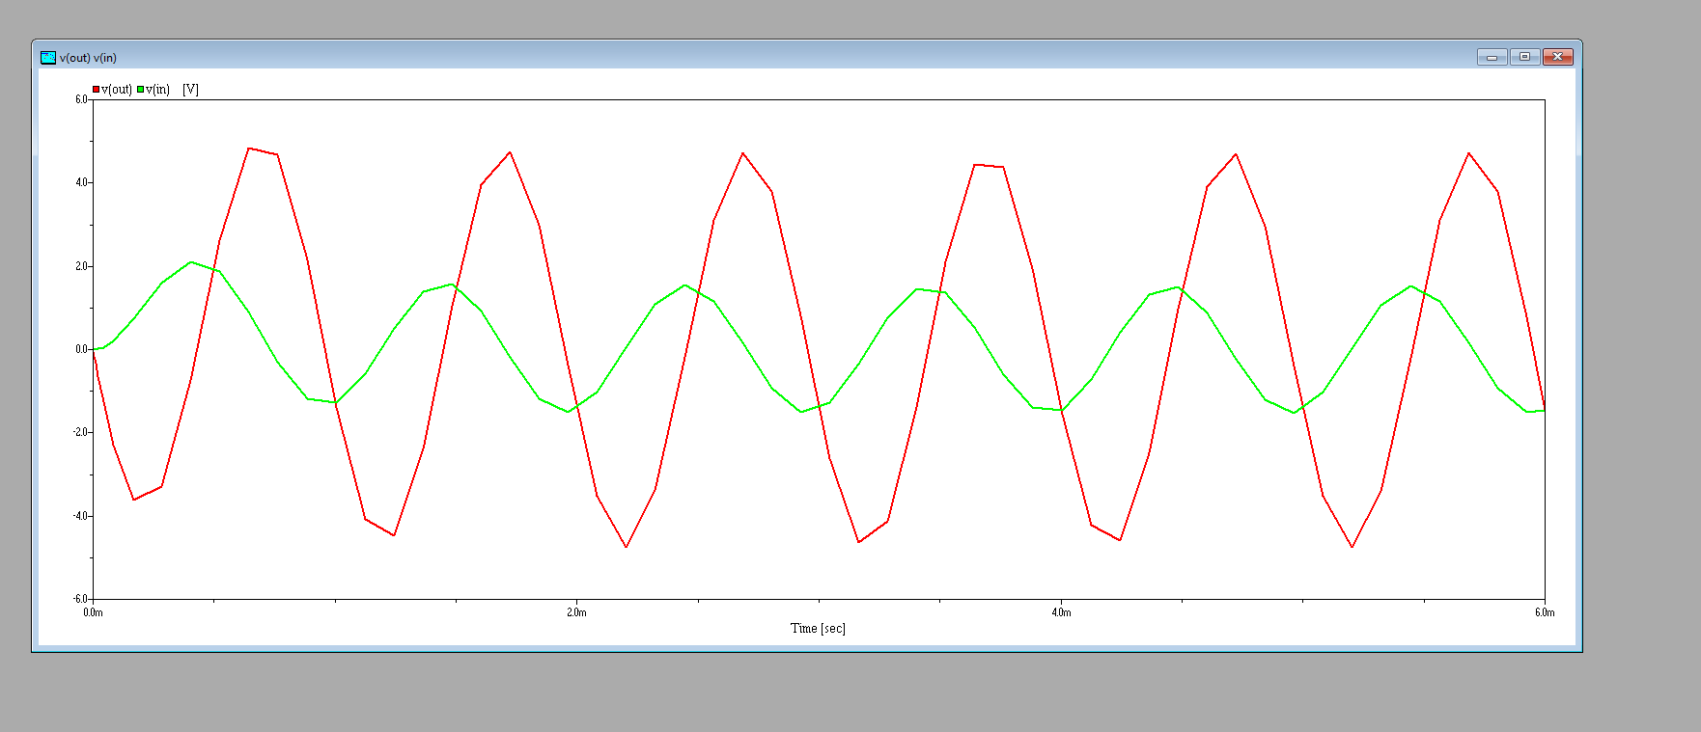

**High – pass filter :**

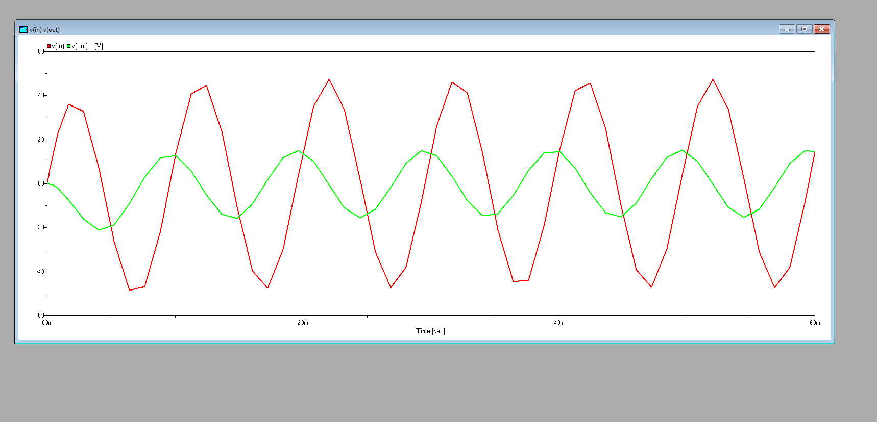

**The code used is here :**

**Low – pass filter :**

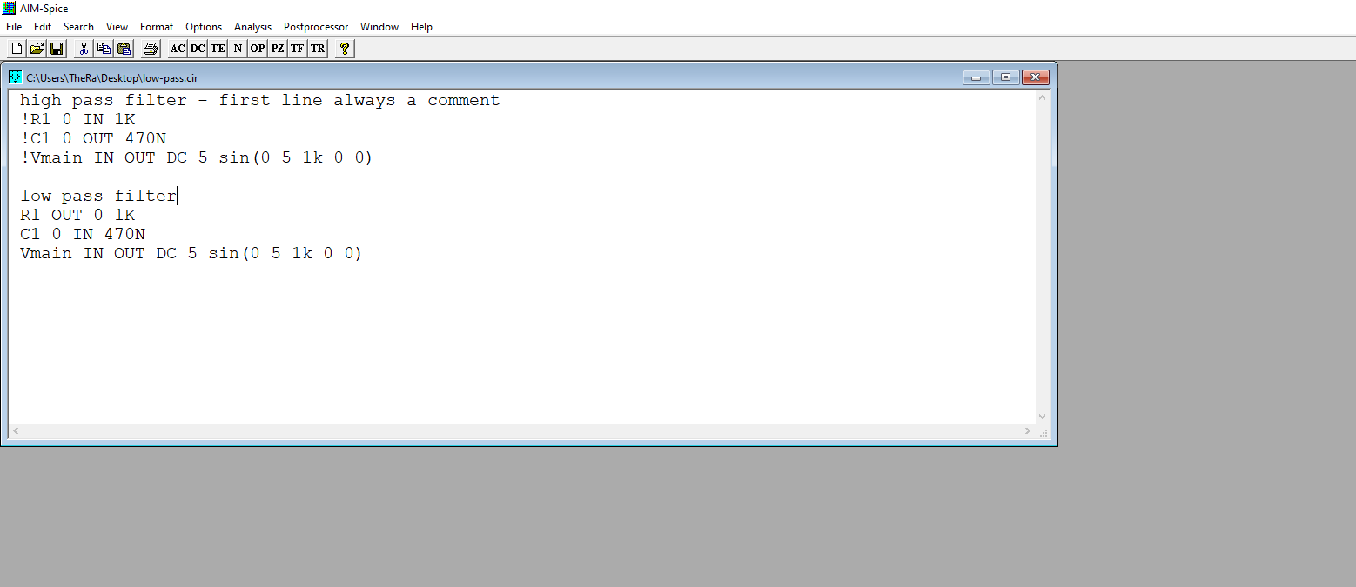

**High – pass filter :**

